Admin app

* To send data in the database which will be retrieved by user app

Planning

Login

Email password

Manual logout

Dashboard

Add notice

Add gallery image

Add eBooks

Update faculty

Update existing

Remove existing

Add new

Delete notice

Using

Material theme

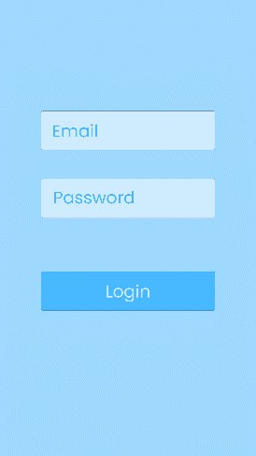

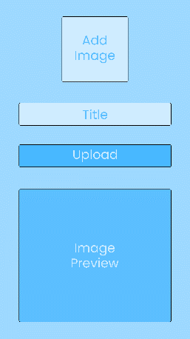 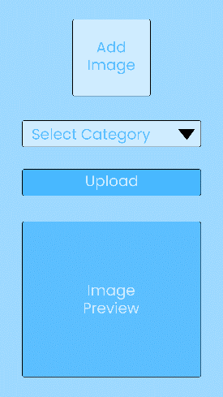

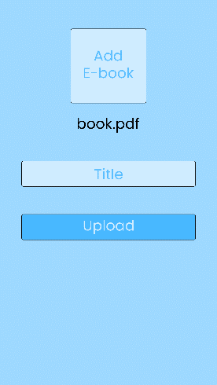 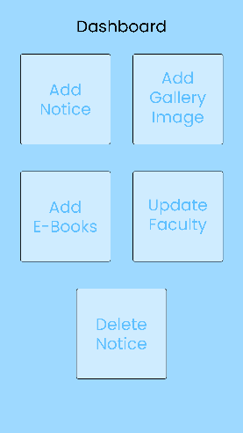 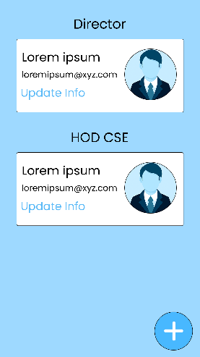

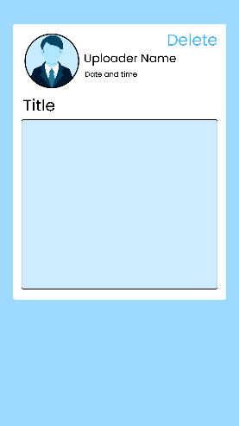 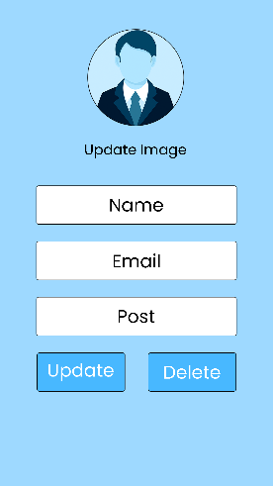 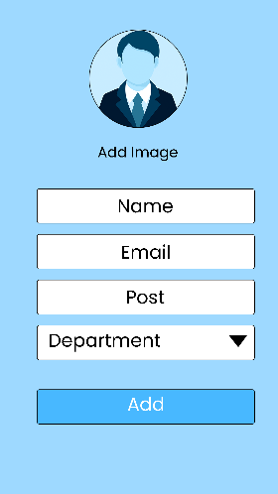

Database structure

News

key

Date

Image

Time

Title

Faculty

Department

Key

Email

Image

Key

Name

Post

Gallery

Event

Image

Pdf

Key

Name

Pdf URL